Welcome to the pages of UN-HABITAT's
Urban Management Programme.

 |  | The Urban Management Programme (UMP) established in 1986, represents a major effort by UN-HABITAT and UNDP, together with external support agencies, to strengthen the contribution that cities and towns in developing countries make towards economic growth, social development and the alleviation of poverty. Over the past 18 years, UMP has been able to promote innovative urban management practices, establish and strengthen municipal networks, and influence local and national urban policies and programmes. As a network of over 40 anchor and partner institutions covering 140 cities in 58 countries, it has been able to provide a platform for partners to engage in work related to emerging urban themes and processes.
  What's new?
  Kisumu declared UN Millennium City.
  Click here for more information
  UN-HABITAT launches Lake Victoria Clean-Up
  Click here for more information
  Localizing MDGs
  Click here for more information
The programme continues to develop and apply urban management knowledge in the fields of participatory urban governance, urban poverty alleviation, urban environmental management and HIV/AIDS. Gender is a cross-cutting theme throughout. UMP's urban management entry point opens up a wealth of opportunities for implementation of the Millennium Development Goals at city level.
Now in Phase 4 (2002 - 2006), the programme is working to institutionalize UMP participatory processes, consolidate experiences and deepen knowledge and understanding of urban management.  UMP has an explicit focus on activities that aim to improve living conditions of the urban poor. From January 2004, the Urban Management Programme has successfully transformed its UMP Regional Offices into a series of UMP Regional Networks, comprised and led by UMP's regional networks of Anchor Institutions.This exciting new development, one that has been planned and prepared for over the past two years, sees UMP goals and activities firmly in the hands of regional and local partners, with continued support from UNDP and UN-HABITAT.
  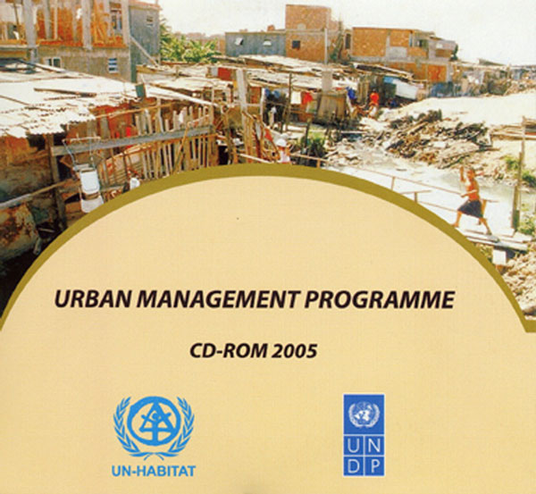
  Urban Management Programme CD-ROM 2005

These networks are expected to intensify the further development, transfer and exchange of the substantive knowledge on various aspects of urban management. They will provide technical and advisory services to local authorities and civil society partners to advocate and influence policy changes at local and national level.  The new regional networks are as follows:  The Africa Network of Urban Management Institutes (ANUMI), based in Abidjan, Cote d'Ivoire.  The Near East and North Africa Urban Forum (NENA), based in Rabat, Morocco. |  | 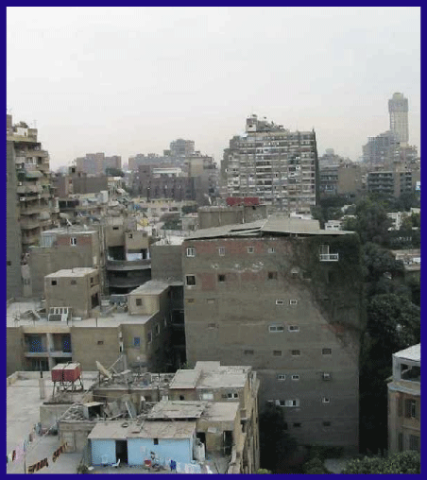
The Urban Resource Centre in Asia Pacific (URCAP) based in Bangkok, Thailand.
The Urban Resource Centre in Latin America and the Caribbean, based in Quito, Ecuador.
Please contact the networks themselves for more details on their objectives and activities.

